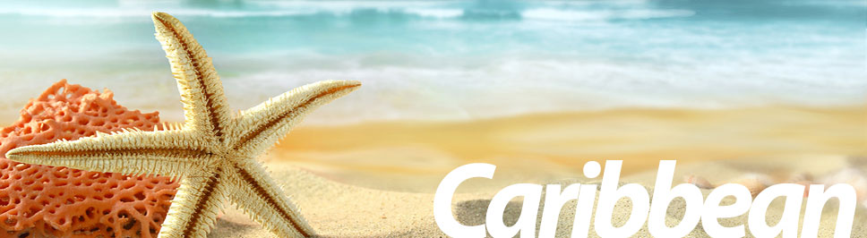
Sandals & Beaches Resorts and Travel Leaders
Invites You to Caribbean Night!
Friday, November 7th at 5:30-7:00 pm

Come and learn all about the beautiful islands of the Caribbean
with Sandals and Beaches Resorts.

Book your Vacation, Family Reunion, Honeymoon or
Special Occasion,
and you may qualify for the following:

  - Up to $250 Spa Credit**
  - Up to 65% Off*
  - Free Nights*
  - Air Credits*
  - Free Weddings
  - Free Honeymoon/Gift Registry
  - Membership to our Sandals Select Program

RSVP: Jodi 719-597-0004 x105
6455 North Union Blvd, Ste 100A

**$250 Spa Credit offered at all Sandals resorts except Grand Pineapple properties ($150 Spa credit at Beaches resorts) with minimum stay of 6 nights in Concierge Category or Higher and booked within 2 weeks from event date. (Not combinable with any other Spa Credit offer). Free nights available at Select Resorts. *Restrictions apply.

